Director of Music Report - 2021

Despite the restrictions imposed by the COVID pandemic, the Church of the Advent Music Ministry continued to make music a part of weekly worship services throughout 2021.For most of the year, Carlos Vasquez, Lindsay Irwin, and Jason Whitney served as song leaders/soloists at both the English and Spanish language services. In the fall, we were pleased to be able to welcome Doris Cedillo and Alice Abundiz back to Church of the Advent as Choral Scholars. After such a long time apart, we were delighted to be able to celebrate Advent and Christmas with the full choir singing together.

As always, our Advent Choir is blessed by the contributions of our scholarship students. Although the Choral Scholars traditionally sing only during the school year, Carlos Vasquez continued to sing at both English and Spanish services throughout summer 2021. We are so grateful to Carlos for his loyal service. Scholarship funds are made possible by donations to the Advent Choral Scholarship Fund. Each student receives a $600 scholarship per semester. In July 2021 an appeal was made to members of the parish for donations to the Choral Scholars fund, and Advent parishioners responded with great generosity.

In the spring, longtime parishioner Olive Rathjen passed away, and her son Fred Rathjen made a generous gift of Olive’s Yamaha grand piano to Church of the Advent. This beautiful instrument now graces our sanctuary, and the gift allowed us to move the fine upright piano that had been donated by the Parker family into our rehearsal room, replacing the previous rehearsal piano which was beyond repair. We are truly blessed by the generosity of our parish family.

An ongoing need is the preservation and maintenance of our valuable and unique Aeolian Skinner pipe organ. In 2021, we were able to perform routine maintenance, but it was necessary to use some of the funds that had been donated to the scholarship fund because there were no funds budgeted for organ and piano maintenance. It is vital that future budgets include funding for routine maintenance of the organ and pianos in order to avoid major expenses due to neglect of regular upkeep. Additional repairs are still needed to restore the organ to full operation. One pressing need involves sealing the bell tower to protect the organ both from the elements and from damage by rodents. It is our hope to address this issue as soon as funds are available.

The Advent Grace Band, which for many years has performed contemporary praise music at various times at the Sunday 10:45 AM services, has been unable to perform during this time of limited gatherings. We look forward to the day when the Grace Band will be able to resume their participation in enriching our worship.

Colin Minkler continues to capably fulfill the position of organist, providing music at all services. Mr. Minkler plays at multiple services each Sunday and has been a vital part of our efforts to continue to include music in our worship services during this difficult year. We are grateful for the gifts of his time and talent.

As 2022 begins, and we have been forced yet again to limit our gatherings, we look forward with hope to the time when we can resume our music ministry in full.

Respectfully submitted,
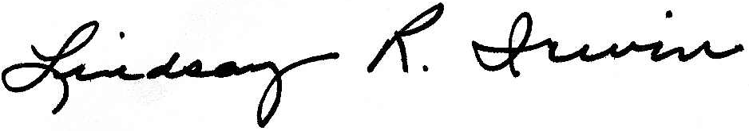
Lindsay R. Irwin
Director of Music

